**THEORY OF COMPUTATIONS**

**LAB PROGRAMMS**

1. **Write a C program to simulate a Deterministic Finite Automata (DFA) for the given language representing strings that start with a and end with a**

**C PROGRAM :**

#include<stdio.h>

#include<string.h>

#define max 20

int main()

{

int trans_table[4][2]={{1,3},{1,2},{1,2},{3,3}};

int final_state=2,i;

int present_state=0;

int next_state=0;

int invalid=0;

char input_string[max];printf("Enter a string:");

scanf("%s",input_string);

int l=strlen(input_string);

for(i=0;i<l;i++)

{

if(input_string[i]=='a')

next_state=trans_table[present_state][0];

else if(input_string[i]=='b')

next_state=trans_table[present_state][1];

else

invalid=l;

present_state=next_state;

}

if(invalid==l)

{

printf("Invalid input");

}

else if(present_state==final_state)

printf("Accept\n");

else

printf("Don't Accept\n");

}

**OUTPUT :**

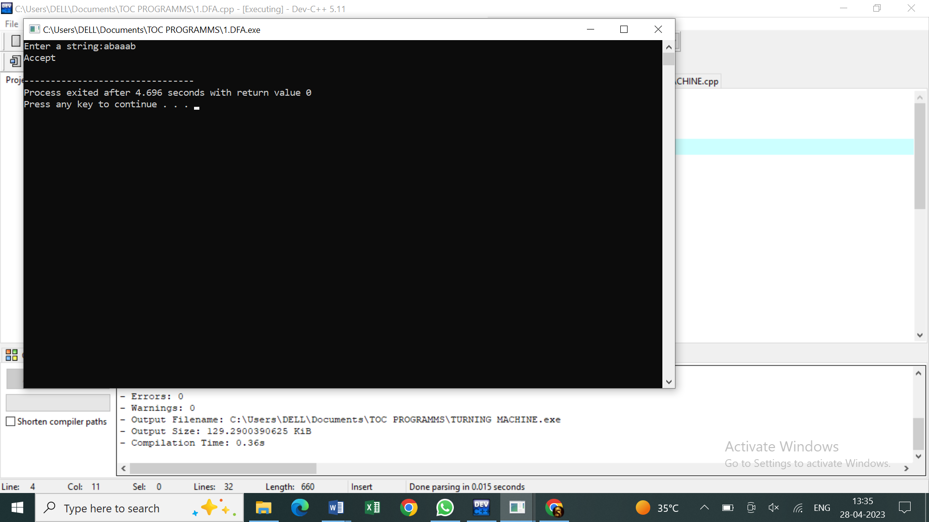

1. **Write a C program to simulate a Deterministic Finite Automata (DFA) for the given language representing strings that start with 0 and end with 1**

**C PROGRAM :**

#include <stdio.h>

int main() {

int state = 0; // Starting state is 0

char input;

printf("Enter a string of 0's and 1's: ");

while((input = getchar()) != '\n') {

switch(state) {

case 0:

if(input == '0') state = 1;

else state = 3;

break;

case 1:

if(input == '0') state = 1;

else if(input == '1') state = 2;

else state = 3;

break;

case 2:

if(input == '0' || input == '1') state = 2;

else state = 3;

break;

case 3:

break;

}

}

if(state == 2) printf("The input string is accepted.\n");

else printf("The input string is not accepted.\n");

return 0;

}

**OUTPUT :**

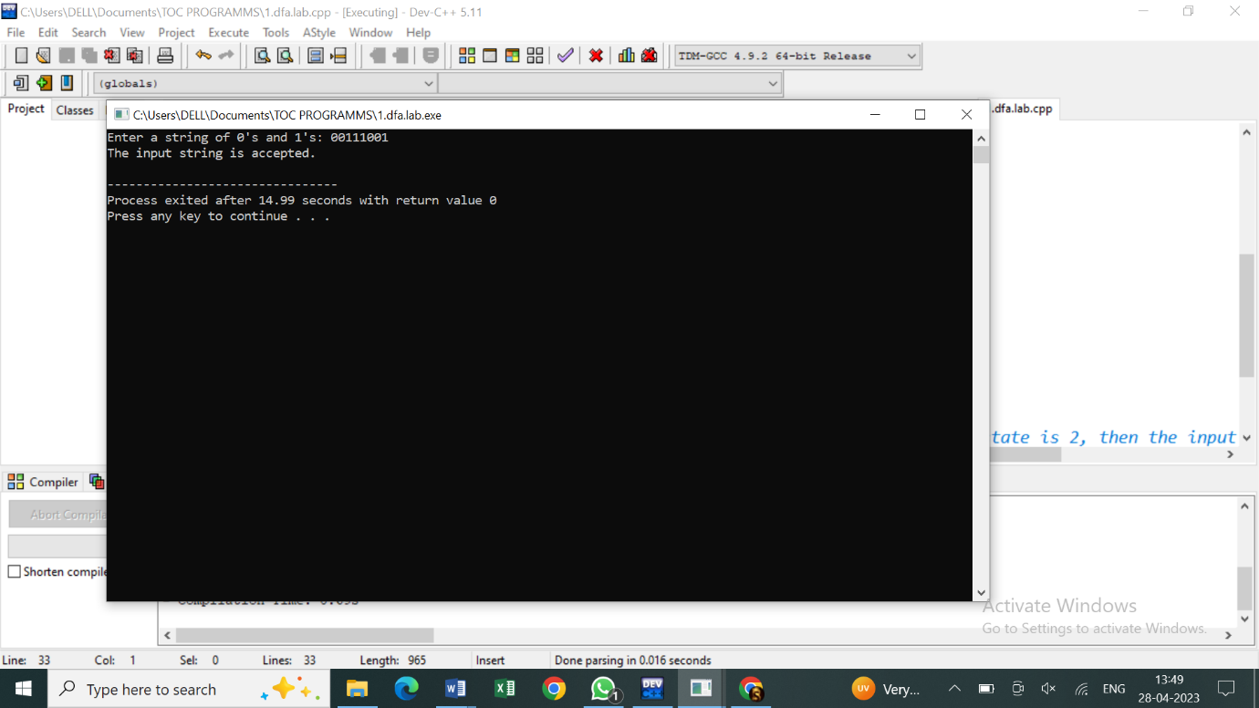

1. **Write a C program to check whether a given string belongs to the language defined by a Context Free Grammar (CFG)**

**S → 0A1**

**A → 0A | 1A | ε**

**C PROGRAM :**

#include<stdio.h>

#include<string.h>

int main(){

char s[100];

int i,flag;

int l;

printf("enter a string to check:");

scanf("%s",s);

l=strlen(s);

flag=1;

for(i=0;i<l;i++)

{

if(s[i]!='0' && s[i]!='1')

{

flag=0;

}

}

if(flag!=1)

printf("string is Not Valid\n");

if(flag==1)

{

if (s[0]=='0'&&s[l-1]=='1')

printf("string is accepted\n");

else

printf("string is Not accepted\n");

}

}

**OUTPUT :**

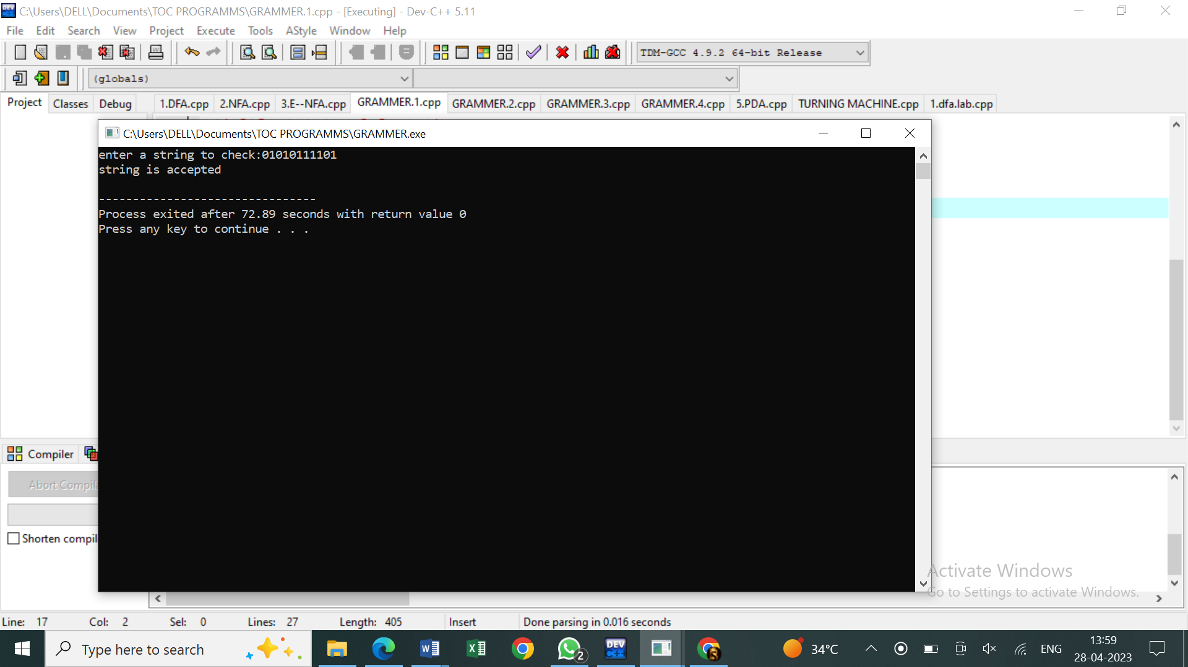

**4.Write a C program to check whether a given string belongs to the language defined by a Context Free Grammar (CFG)**

**S → 0S0 | 1S1 | 0 | 1 | ε**

**C PROGRAM :**

#include<stdio.h>

#include<string.h>

int main()

{

char s[100];

int i,flag,flag1,a,b;

int l;

printf("enter a string to check:");

scanf("%s",s);

l=strlen(s);

flag=1;

for(i=0;i<l;i++)

{

if(s[i]!='0' && s[i]!='1')

{

flag=0;

}

}

if(flag!=1)

printf("string is Not Valid\n");

if(flag==1)

{

flag1=1;

a=0;b=l-1;

while(a!=(l/2))

{

if(s[a]!=s[b])

{

flag1=0;

}

a=a+1;

b=b-1;

}

if (flag1==1)

{

printf("The string is a palindrome\n");

printf("string is accepted\n");

}

else

{

printf("The string is not a palindrome\n");

printf("string is Not accepted\n");

}

}

**OUTPUT :**

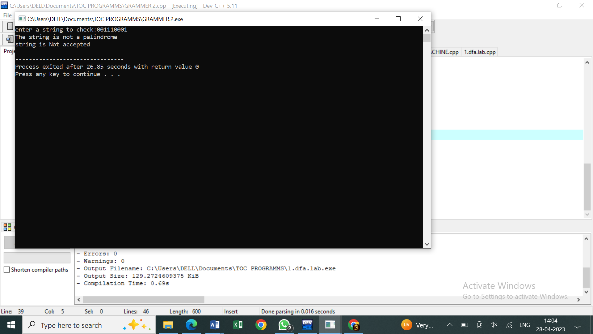

1. **Write a C program to check whether a given string belongs to the language defined by a Context Free Grammar (CFG)**

**S → 0S0 | A**

**A → 1A | ε**

**C PROGRAM :**

#include<stdio.h>

#include<string.h>

int main()

{

char s[100];

int i,flag,flag1,a,b;

int l,count1,count2;

printf("enter a string to check:");

scanf("%s",s);

l=strlen(s);

flag=1;

for(i=0;i<l;i++)

{

if(s[i]!='0' && s[i]!='1')

{

flag=0;

}

}

if(flag!=1)

printf("string is Not Valid\n");

if(flag==1)

{

i=0;count1=0;

while(s[i]=='0') // Count the no of 0s in the front

{

count1++;

i++;

}

while(s[i]=='1')

{

i++; // Skip all 1s

}

flag1=1;

count2=0;

while(i<l)

{

if(s[i]=='0')// Count the no of 0s at the end

{

count2++;

}

else

{

flag1=0;

}

i++;

}

if(flag1==1)

{

if(count1==count2)

{

printf("The string satisfies the condition 0n1m0n\n");

printf("String Accepted\n");

}

else

{

printf("The string does not satisfy the condition 0n1m0n\n");

printf("String Not Accepted\n");

}

}

else

{

printf("The string does not satisfy the condition 0n1m0n\n");

printf("String Not Accepted\n");

}

}

}

**OUTPUT :**

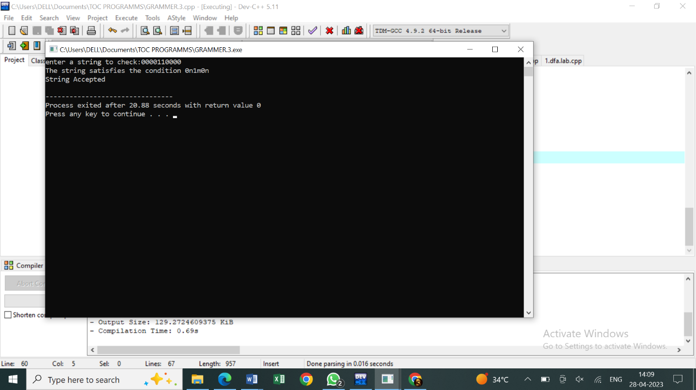

1. **Write a C program to check whether a given string belongs to the language defined by a Context Free Grammar (CFG)**

**S → 0S1 | ε**

**C PROGRAM :**

#include<stdio.h>

#include<string.h>

int main()

{

char s[100];

int i,flag,flag1,flag2;

int l;

printf("enter a string to check:");

scanf("%s",s);

l=strlen(s);

flag=1;

for(i=0;i<l;i++)

{

if(s[i]!='0' && s[i]!='1')

{

flag=0;

}

}

if(flag!=1)

printf("string is Not Valid\n");

if(flag==1)

{

if(l%2!=0) // If string length is odd

{

printf("The string does not satisfy the condition 0n1n\n");

printf("String Not Accepted\n");

}

else

{

// To check first half contains 0s

flag1=1;

for(i=0;i<(l/2);i++)

{

if(s[i]!='0')

{

flag1=0;

}

}

// To check second half contains 1s

flag2=1;

for(i=l/2;i<l;i++)

{

if(s[i]!='1')

{

flag2=0;

}

}

if(flag1==1 && flag2==1)

{

printf("The string satisfies the condition 0n1n\n");

printf("String Accepted\n");

}

else

{

printf("The string does not satisfy the condition 0n1n\n");

printf("String Not Accepted\n");

}

}

}

}

**OUTPUT :**

